**Question 1 & 2:**

* Uint8 stands for unsigned integer. The reason we use it to store a pixel is since the maximum value for RGB channels is 255 which is in range.
* It has 12.2 megapixels.

**Question 3-6:**

**Original image**

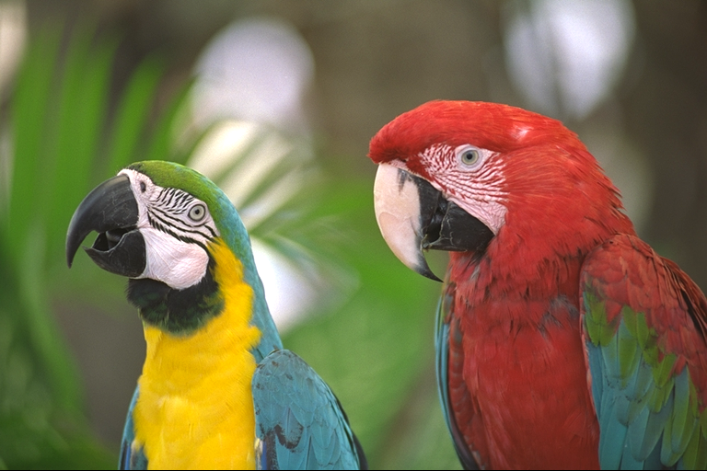

**Gray scale image**

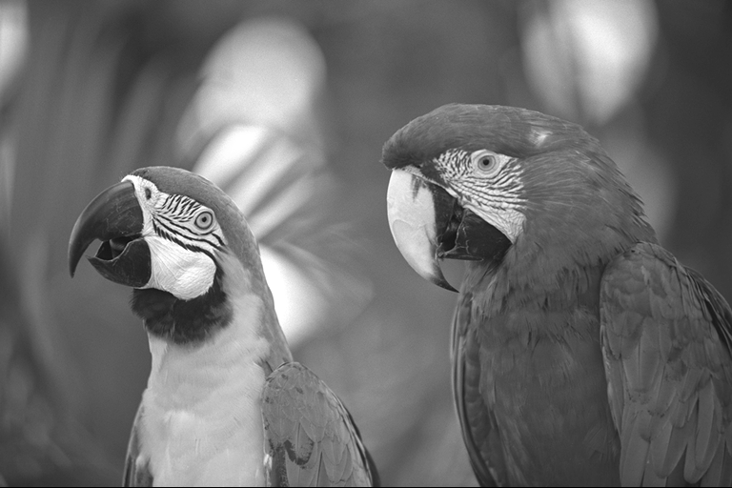

**Higher contrast image**

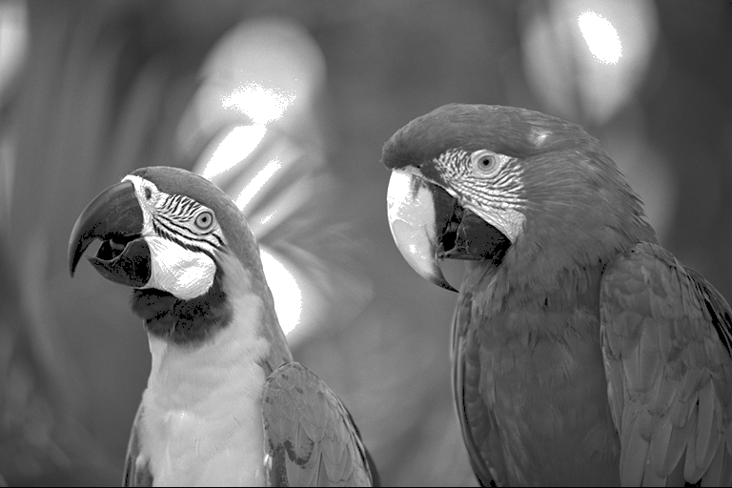

**Code**

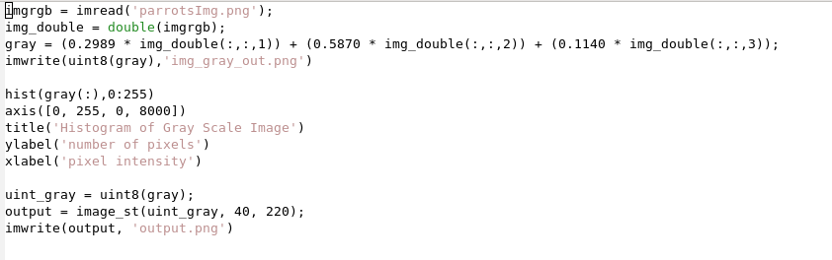

**Question 7,8:**

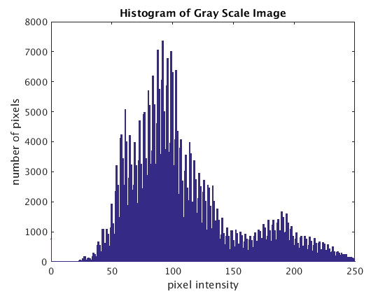

**Question 9:**

I observed that the darker pixels got darker and lighter pixels got lighter. Playing around with with the values for T1 & T2 I observed that raising T1 makes more pixels lighter and lowering T2 makes more pixels darker.

**Question 10:**

When T1 was set to minimum pixel intensity and T2 was set to maximum pixel intensity there was no effect on the image. This is because in this case there is no range for T1 and T2 where it darkens or lightens the image as it is on the edges.